**Convolution Neural Networks for TSC**

CNN helps the machine to view the world as humans do, since the architecture of the CNN is analogous to that of the connectivity pattern of the neurons in the human brain and was inspired by the organization of the visual cortex.

CNN algorithm takes an input images, assign importance to various aspects or objects in the images and be able to differentiate one from another.

The preprocessing required for CNN is much less than the other classification algorithms.

**Two phases of CNN algorithm from TSC**

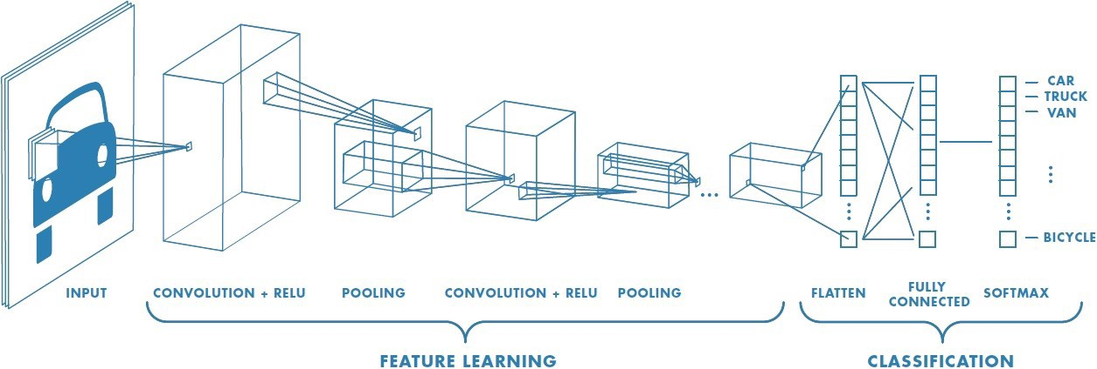

* Feature Learning
  + Convolution + RELU
  + Pooling
* Classification
  + Flatten
  + Fully connected feed forward neural network with back propagation
  + SoftMax classification algorithm

CNN is able to successfully capture the spatial and temporal dependencies in an image through the application of relevant filters.

CNN reduces the images into a form which is easier to process, without losing the features which are critical for getting a good prediction.

**The kernel/Filter**

It is the element that is involved in carrying out the convolution operation in the first part of a convolution layer.

In over program

* The size of the images after the image augmentation will be 32 x 32
* 1st conv2d layer - 60 filters with 5x5 filter
* 2nd conv2d layer- 60 filters with 5x5 filter
* 3rd conv2d layer- 30 filters with 3x3 filter
* 4th conv2d layer- 30 filters with 3x3 filter

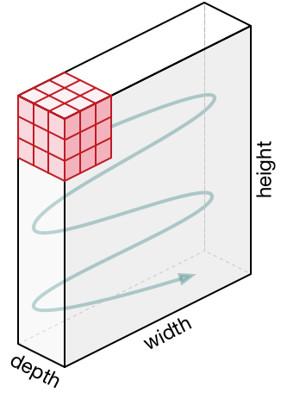

Movement of the kernel

The first convolution layers extract the low-level features such as edges, colors, gradient orientation etc. But with added layers we can extract high level features also.

**Pooling Layer**

* Pooling layer is responsible for reducing the spatial size of the convolved feature. This is to decrease the computational power required to process the data through dimensionality reduction.
* Also extract the dominant features which are rotational and positional invariant.

Max pooling is better than average pooling.

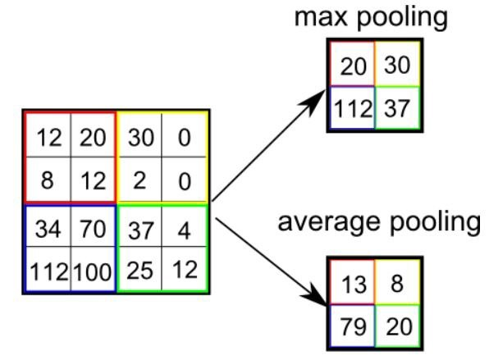

Comparing Maxpooling and Average Pooling

**Activation Function**

This decides whether a neuron should be activated or not by calculation a weighted sum and further adding bias to it.

Helps understand the complex patterns in the data

**RELU**

* One of the most popular activation function.
* Rectified Linear Unit

**Classification Phase**

The output from the feature extraction phase is flattened into a column vector. That is fed to a feed forward neural network and backpropagation is applied at every iteration of the training.

Over the series of epochs, the model is able to distinguish between the dominating and certain low-level features in images and classify them using the SoftMax classification technique.

**SoftMax Activation Function**

Converts a vector of numbers into a vector of probabilities.

**Backpropagation**

Calculate the gradient of a loss function with respects to the weights in the network.

After rach feed forward passes through a network, this algorithm does the backward pass to adjust the models parameters based on weights and biases.